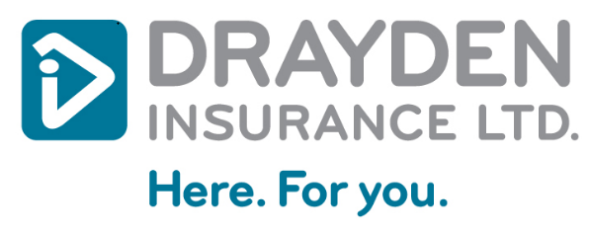
-Two copies of this Bill of Sale should be completed. The buyer keeps the original and the seller keeps the copy.
-Alterations or corrections made while completing the Bill of Sale must be initialled by both buyer and seller.

BILL OF SALE SECTION 1
SELLER(S) INFORMATION
Name(s) |  |  |  |  |  |  |  | Phone
Address
City |  |  |  |  | Province |  |  | Postal Code
Personal Identification
VEHICLE INFORMATION
Year | Make |  |  | Model or Series |  |  |  |  |  | Body Colour
Vehicle Identification Number (VIN) / Serial Number |  |  |  | Odometer Reading |  |  |  |  |  | Style
BUYER(S) INFORMATION
Name(s) |  |  |  |  |  |  |  | Phone
Address
City |  |  |  |  | Province |  |  |  | Postal Code
Personal Identification
This vehicle was sold for the sum of:  _______________  (Sum written in full)  (Subject to the terms and special conditions, which appear in Section 3 on the back of this form) |  |  |  |  |  |  | Dollars $
Dated on  YYYY-MM-DD |  |  | at  City/Town Province/State Country
I certify that all information shown above is true to the best of my knowledge.
______________________________ ______________________________ Signature of Buyer Signature of Seller
______________________________ ______________________________ Signature of Buyer Signature of Seller
______________________________ ______________________________ Signature of Witness Signature of Witness

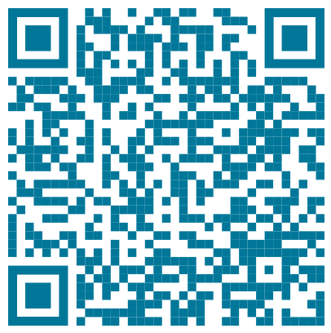
Registered your new vehicle? Sign up for Automatic Vehicle Registration Renewals and we’ll do it for you every year!
SECTION 2 (Optional)
SPECIAL CONDITIONS OF SALE
- The vehicle described in Section 1 of this form is:
  - Free of all liens and encumbrances: ☐ Yes ☐ No If No, please give names of lien holders
  - Being paid for in full: ☐ Yes ☐ No
  - Being paid by: ☐ Cash ☐ Cheque ☐ Money Order ☐ Other (Please specify):
- Payment Terms:
- The Vehicle was last registered in:
- Special conditions of sale (If any):

- Before buying a used vehicle, search the VIN (www.cpic-cpic.ca) for any reports of the vehicle being stolen. For other motor vehicle buying tips visit amvic.org and alberta.ca
- The law in the Province of Alberta requires a vehicle to be insured prior to registration. Documentary proof of vehicle insurance is required.
- A vehicle entering Alberta from another jurisdiction requires a safety inspection. Information can be obtained from a Registry Agent. A listing of local Registry Agents can be found in the telephone directory under Licence and Registry Services; or visit Service Alberta's website at www.servicealberta.gov.ab.ca for comprehensive registries and consumer information and services.
- In addition to the Bill of Sale, other identification is required to obtain Alberta registration. Where possible, obtain Section 2 of the previous Alberta vehicle registration certificate.
- The prospective purchaser can determine whether a vehicle is free of liens and encumbrances in Alberta by contacting a Registry Agent. In order to perform a search, a Registry Agent will require the vehicle identification number (VIN) / serial number of the vehicle. A request for a search can be made in person or in writing. There is a fee for this service.
- Vehicle Information Reports are available from a Registry Agent. There is a fee for each service.
- The buyer must produce a copy of a properly completed Bill of Sale, that includes the same information as shown on this standardized form, in order to register and licence a vehicle in Alberta.
This form is provided as a courtesy by Service Alberta to ensure that sufficient information is contained within the Bill of Sale to permit licensing and registration of the described vehicle by the new owner.
No liability attaches to Drayden through the use of this document in respect of the sale of this vehicle. Any dispute arising from the sale becomes a civil matter among the parties named in this document.

